POLICY
The Upstate Carolina NCORP (UC-NCORP) requires reporting of Unanticipated Problems and Continuing or Serious Noncompliance to the Regulatory Office within 48 hours of discovery.

RESPONSIBILITY
Affiliate Site for reporting
Regulatory Manager for submission

DEFINITIONS
Unanticipated Problem: This includes Serious Adverse Events (SAEs). Unanticipated problems include any incident, experience, or outcome that meets ALL the following criteria:
- The incident, experience, or outcome is unexpected (in terms of nature, severity, or frequency) given the research procedures that are described in the protocol or the investigator’s brochure and the characteristics of the subject population being studied;
- There is a reasonable possibility that the incident, experience, or outcome may have been caused by the procedures involved in the research; and
- Subjects or others are at a greater risk of harm (including physical, psychological, economic, or social harm) than was previously known or recognized due to the incident, experience, or outcome.

Unexpected: The NCI CIRB defines “unexpected” as incidents, experiences, or outcomes that occur while the CIRB-approved protocol is followed as written. These events are unexpected as they are not included in the CIRB-approved protocol, CIRB-approved informed consent document, or the Investigator's Brochure.

Noncompliance is a failure to follow protocol or federal regulations. This includes protocol deviations.

Serious noncompliance is noncompliance that adversely affects the rights and welfare of study participants or results in any untoward medical occurrence that meets the criteria of “serious” or significantly impacts the integrity of study data.

Serious is defined as side effects that may require hospitalization or may be irreversible, long-term, life-threatening, or fatal. The NCI CIRB may also consider as serious those events which, based on appropriate medical judgment, may jeopardize the patient or subject and am require medical or surgical intervention to prevent one of the outcomes above.

Signatory Institution Principal Investigator: Protocol investigator responsible for reporting to cooperative group and NCI CIRB. Also referred to as “Study Principal Investigator”

Continuing noncompliance is a systematic and habitual disregard of the requirements or decisions of the NCI CIRB or of Federal regulations. Continuing noncompliance is an indication of a pattern that, if unaddressed, could jeopardize the rights and welfare of research participants or the integrity of the study data due to noncompliance with the protocol, Federal regulations, and/or the requirements of the NCI CIRB.

GUIDELINES
The Signatory Institution Principal Investigator is required to report serious adverse events and protocol deviations to the Research Base, per the Group’s guidelines. These events are also reported to the NCI CIRB when the Principal Investigator believes they represent a potential unanticipated problem or serious or continuing noncompliance.

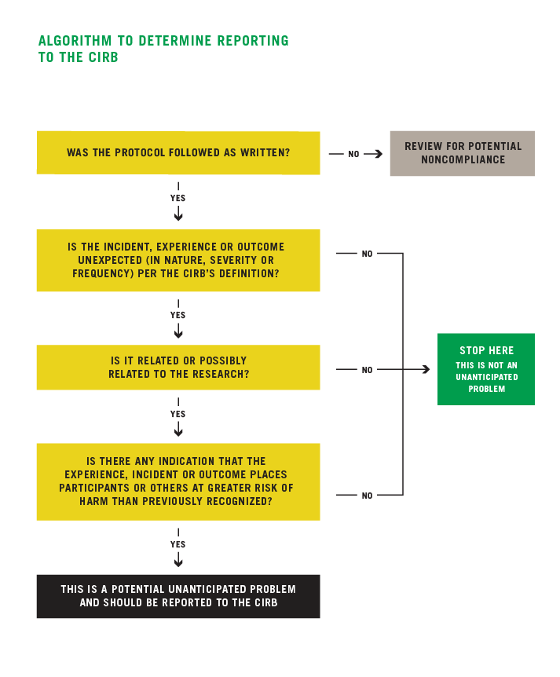
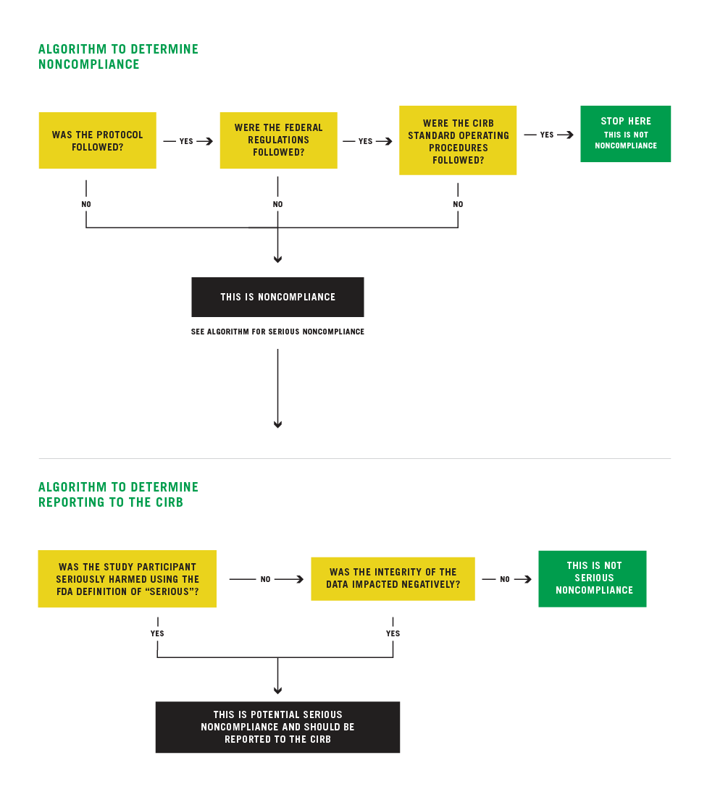

PROCEDURES
Affiliate Staff:
- Research staff will determine reportable events using the guidelines above. If questions, the Consortium’s regulatory office can be consulted.
- Research staff will fax or email the reporting worksheet to the Regulatory Office within 48 hours of discovery of a reportable event.
- Regulatory staff will submit the reports to NCI CIRB electronically per NCI CIRB SOPs.

Consortium Staff:
- Regulatory staff will immediately notify Consortium Principal Investigators of unanticipated problems or continuing noncompliance that jeopardizes patient safety.

REFERENCE:
45 CFR 46.103(b)(5) and 21 CFR 56.108(b)(1)
NCI CIRB SOPs

ASSOCIATED FORMS:
Unanticipated Problem and/or Noncompliance Reporting Worksheet (CIRB)

COMMITTEE APPROVAL:
UC Policy and Procedure Committee

